LOVELY PROFESSIONAL UNIVERSITY
Academic Task-3 (Operating System)
CSE316

Submitted By:

Student Name: SATYAM KUMAR RAY

Registration No.: 11809778

Email : satyamray15@gmail.com

GitHub Link: https://github.com/SatyamRay15/Operating_System_Assignment

Submitted To:

Name of the faculty: Milanjit Kaur

Question 17

Design a scheduler following non-preemptive scheduling approach to schedule the processes that arrives at different units and having burst time double the arrival time. Scheduler selects the process with largest burst time from the queue for the execution. Process is not being preempted until it finishes its service time. Compute the average waiting time and average turnaround time. What should be the average waiting time if processes are executed according to Shortest Job First scheduling approach with the same attribute values.

Description:
This is a program written in C language. Here we have used all the necessary header files required to run this program like <stdio.h>, <unistd.h> and <fcntl.h>. It is a program to design a scheduler following non-preemptive scheduling to schedule the processes that arrives at different units. Here scheduler is the system which decides the order in which the processes is to be assigned to the CPU. In this program, the burst time of the process is double the arrival time. We will be taking the number of processes to be executed by the user and also the arrival time. Burst time will be automatically allocated. Scheduler sorts all the processes and selects the largest burst time from the queue for execution. All the processes are executed in sequence and is not being preempted until it finishes its service time. Then the average waiting time and average turnaround time is calculated. Then the average waiting time is calculated when the processes are executed according to Shortest Job First (SJF) scheduling approach with the same attribute values.

Algorithm:

- Start the program.
- Take the number of processes to be executed from the user.
- Take the arrival time of each process from the user and store them in an array.
- Multiply each process by 2 using for loop to make Burst time double the Arrival time and store them in an array.
- Sort the processes in decending order.
- Select the process which is having the largest Burst Time.
- Exexute the processes in sequence using a function call.
- Compute the complete time of each process after all the processes are executed.
- Compute the Turnaround Time of each process using the formulae TAT=CT-AT
- Compute the Waiting Time of each process using the formulae WT=TAT-BT
- Print the final table.
- Compute the Average Turnaround Time and print.
- Compute the Average Waiting Time and print.
- Using the same arrtibute values taken from the user //SJF(Non-Preemption)
- Sort the processes in ascending order.
- Select the process which is having the lowest Arrival Time.
- Execute the processes in sequence as the Burst time is double the Arrival Time.
- Compute the complete time of each process after all the processes are executed.
- Compute the Turnaround Time of each process using the formulae TAT=CT-AT
- Compute the Waiting Time of each process using the formulae WT=TAT-BT
- Print the final table of SJF.
- Compute the Average Turnaround Time of SJF and print.
- Compute the Average Waiting Time of SJF and print.
- End the program.

CODE OF THE PROGRAM:

//Qusetion Number 17 Project done by:Satyam Kumar Ray Registration No.:11809778 //Roll No.:B63
//Header Files
#include<stdio.h>
#include<unistd.h>
#include<fcntl.h>

int function(int a) //Function to execute the process
{
printf("Process with %d burst time is under execution. \n", a);
sleep(a);
printf("The execution of the process with %d burst time is completed.\n",a);
printf("\n");
}

int main() //Main process
{
//Declaration of variables
int j;
float Tat=0, Wat=0, sjf_Tat=0, sjf_Wat=0;

//The number of processes taken from user
printf("Enter the number of processes to be executed: \n");
scanf("%d",&j);

//Declaration of variables
int burst_time[j], arrival_time[j], complete_time[j], turnaround_time[j], waiting_time[j];
int sjf_at[j], sjf_bt[j], sjf_complete_time[j], sjf_turnaround_time[j],sjf_waiting_time[j];
int process_id[j], sjf_process_id[j];

//Arrival time taken from the user
printf("Enter the values of arrival time: \n");
for(int i=1;i<=j;i++) //Complexity: O(n)
{
scanf("%d",&arrival_time[i]);
sjf_at[i]=arrival_time[i];
}

//Burst Time is doubled here by multiplying by two
for(int i=1;i<=j;i++) //Complexity: O(n)
{
burst_time[i] = arrival_time[i] * 2;
sjf_bt[i]=burst_time[i];
}

//Printing the initial Table
printf("The table is as follows:\n");
printf("PROCESS ID\t ARRIVAL TIME\t BURST TIME \n");
for(int i=1;i<=j;i++) //Complexity: O(n)
{
process_id[i]=i; //As this process array is empty, we are allocating the values to it.
printf(" P%d\t\t %d\t\t %d \n",process_id[i],arrival_time[i],burst_time[i]);
}

//Here we are using the sorting method to sort the processes and select the largest from it
printf("The value with the largest burst time will be selected: \n");
for(int k=1;k<=j;k++) //Complexity: O(n)
{
for(int i=1;i<j;i++) //Complexity: O(n)
{
if(burst_time[i]<=burst_time[i+1])
{
//Swapping is done here if the above if condition is true
int temp; //Swapping of Burst Time
temp=burst_time[i+1];
burst_time[i+1]=burst_time[i];
burst_time[i]=temp;

temp=arrival_time[i+1]; //Swapping of Arrival Time
arrival_time[i+1]=arrival_time[i];
arrival_time[i]=temp;

temp=process_id[i+1]; //Swapping of Process Id
process_id[i+1]=process_id[i];
process_id[i]=temp;
}
}
}

//The Table which is displayed after the sorting is done
printf("The sequence of the execution after selecting the largest BT is given below Table: \n");
printf("PROCESS ID\t ARRIVAL TIME\t BURST TIME \n");
for(int i=1;i<=j;i++) //Complexity: O(n)
{
printf(" P%d\t\t %d\t\t %d \n",process_id[i],arrival_time[i],burst_time[i]);
}

//Here the processes will be executed using function which is on the top (Function Call)
for(int i=1;i<=j;i++) //Complexity: O(n)
{
int number;
number=function(burst_time[i]);
}
printf("Now all the process have been executed. \n");
printf("\n");

//Here complete time is calculated. As the arrival time of the largest process is taken first, //the first
//arrival time is added in order to keep the consistency and to find out the accurate Wating //time and TAT
int sum=arrival_time[1];
for(int i=1;i<=j;i++) //Complexity: O(n)
{
sum=sum+burst_time[i];
complete_time[i]=sum;
}

//Here the Turnaround Time is calculated using the formula TAT=Complete Time-Arrival //Time
for(int i=1;i<=j;i++) //Complexity: O(n)
{
turnaround_time[i]=complete_time[i]-arrival_time[i];
Tat=Tat+turnaround_time[i];
}

//Here the Waiting Time is calculated using the formulae Waiting=TAT-Burst Time
for(int i=1;i<=j;i++) //Complexity: O(n)
{
waiting_time[i]=turnaround_time[i]-burst_time[i];
Wat=Wat+waiting_time[i];
}

//Here the final Table is displayed. All the values are displayed
printf("The final table is as follows: \n");

printf("PROCESS ID\t ARRIVAL TIME\t BURST TIME\t COMPLETE TIME\t TURNAROUND TIME\t WAITING TIME \n");
for(int i=1;i<=j;i++) //Complexity: O(n)
{
printf(" P%d\t\t %d\t\t %d\t\t %d\t\t %d\t\t\t %d \n",process_id[i],arrival_time[i],burst_time[i],complete_time[i],turnaround_time[i],waiting_time[i]);
}

//Here the average Turnaround Time is calculated and displayed
Tat=Tat/j;
printf("The average Turn Around Time of the overall process is: %f \n",Tat);

//Here the Average Waiting Time is calculated and displayed
Wat=Wat/j;
printf("The average Waiting Time of the overall process is: %f \n", Wat);

//Shortest Job First
//Table of the SJF is displayed using the same same attribute values
printf("\n");
printf("The table for SHORTEST JOB FIRST is as follows:\n");
printf("PROCESS ID\t ARRIVAL TIME\t BURST TIME \n");
for(int i=1;i<=j;i++) //Complexity: O(n)
{
sjf_process_id[i]=i;//As this process array is empty, we are allocating the values to it.
printf(" P%d\t\t %d\t\t %d \n",sjf_process_id[i],sjf_at[i],sjf_bt[i]);
}

//Here we are sorting the processes into acending order. If we want to execute the processes //having lowest burst
//time which will be automatically having the lowest arrival time.
for(int l=1;l<=j;l++) //Complexity: O(n)
{
for(int i=1;i<j;i++) //Complexity: O(n)
{
if(sjf_bt[i]>=sjf_bt[i+1])
{
//Swapping is done if the above if condition is true
int temporary;
temporary=sjf_at[i+1]; //Swapping of arrival time
sjf_at[i+1]=sjf_bt[i];
sjf_bt[i]=temporary;

temporary=sjf_bt[i+1]; //Swapping of burst time
sjf_bt[i+1]=sjf_bt[i];
sjf_bt[i]=temporary;

temporary=sjf_process_id[i+1]; //Swapping of process id
sjf_process_id[i+1]=sjf_process_id[i];
sjf_process_id[i]=temporary;
}
}
}

//Here we will be printing the Table after sorting is done
printf("The sequence of the execution after selecting the largest BT is given below Table: \n");
printf("PROCESS ID\t ARRIVAL TIME\t BURST TIME \n");
for(int i=1;i<=j;i++) //Complexity: O(n)
{
printf(" P%d\t\t %d\t\t %d \n",sjf_process_id[i],sjf_at[i],sjf_bt[i]);
}

//Here we are calculating the Complete Time using SJF (Non-Preemption)
int sum1=0;
for(int i=1;i<=j;i++) //Complexity: O(n)
{
sum1=sum1+sjf_bt[i];
sjf_complete_time[i]=sum1;
}

//Here the Turnaround Time using SJF(Non-preemption) is calculated using the formula //TAT=Complete Time-Arrival Time
for(int i=1;i<=j;i++) //Complexity: O(n)
{
sjf_turnaround_time[i]=sjf_complete_time[i]-sjf_at[i];
sjf_Tat=sjf_Tat+sjf_turnaround_time[i];
}

//Here the Waiting Time using SJF(Non-preemption) is calculated using the formulae //Waiting=TAT-Burst Time
for(int i=1;i<=j;i++) //Complexity: O(n)
{
sjf_waiting_time[i]=sjf_turnaround_time[i]-sjf_bt[i];
sjf_Wat=sjf_Wat+sjf_waiting_time[i];
}

//Here the final table is being printed
printf("This is the final table using Shortest Job First \n");
printf("PROCESS ID\t ARRIVAL TIME\t BURST TIME\t COMPLETE TIME\t TURNAROUND TIME\t WAITING TIME\t \n");
for(int i=1;i<=j;i++) //Complexity: O(n)
{
printf(" P%d\t\t %d\t\t %d\t\t %d\t\t %d\t\t\t %d \n",sjf_process_id[i],sjf_at[i],sjf_bt[i],sjf_complete_time[i],sjf_turnaround_time[i],sjf_waiting_time[i]);
}

//Here the Average Turnaround Time is being calculated and printed in SJF
sjf_Tat=sjf_Tat/j;
printf("\n Average Turnaround Time using SJF (Non-Preemption) is: %f",sjf_Tat);

//Here the Average Waiting Time is being calculated and printed in SJF
sjf_Wat=sjf_Wat/j;
printf("\n Average Waiting Time using SJF (Non-Preemption) is: %f",sjf_Wat);

return 0;
}

Complexity of Implemented Algorithm

In the above program the complexity is written where ever need. For every for loop used we have the time complexity as O(n) and there are 19 for loops in the program for sorting, printing,calculating,etc. In rest of the code written, the complexity remains constant as we use if conditions, initiliazation,etc. Therefore the overall complexity of the program is O(n²).

Constraints

- In this program only integer values can be taken from the user, as number of processes cannot be a float value or decimal value.
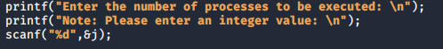
- The arrival time is also taken as integer value in order to reduce the inconsistency.
- It needs to be implemented in non-preemptive scheduling approach to schedule the processes that arrives at different units and having burst time double the arrival time.
- The process with largest burst time is to be selected from the queue for the execution.
- Average Waiting Time and Average Turnaround Time is to be computed.
- The average waiting time is to be claculated if the processes are executed according to Shortest Job First scheduling approach with the same attribute values.
- The code written here for SJF(Non-Preemptive) will only work for this program and not for all values as the Burst Time is double the Arrival Time.

Code Snippet

- CODE: Here the pictures of the program is added. In the given 1st pictures, it is all about starting the program. Including all the header files and initiliazing variables,etc.
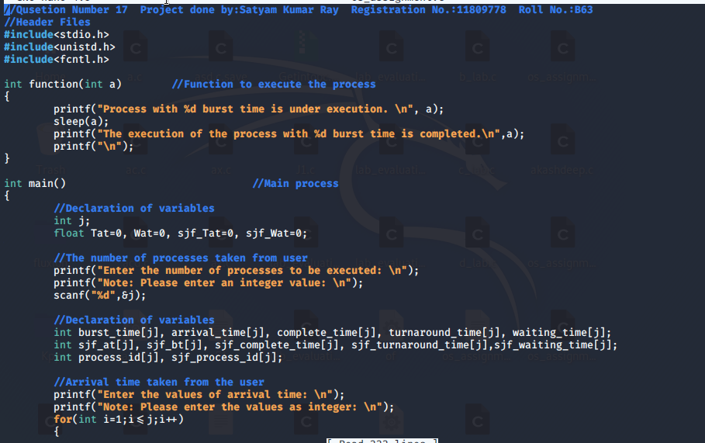
scanf(“%d”,&arrival_time[i]); //I have written here as it was missed in the snip
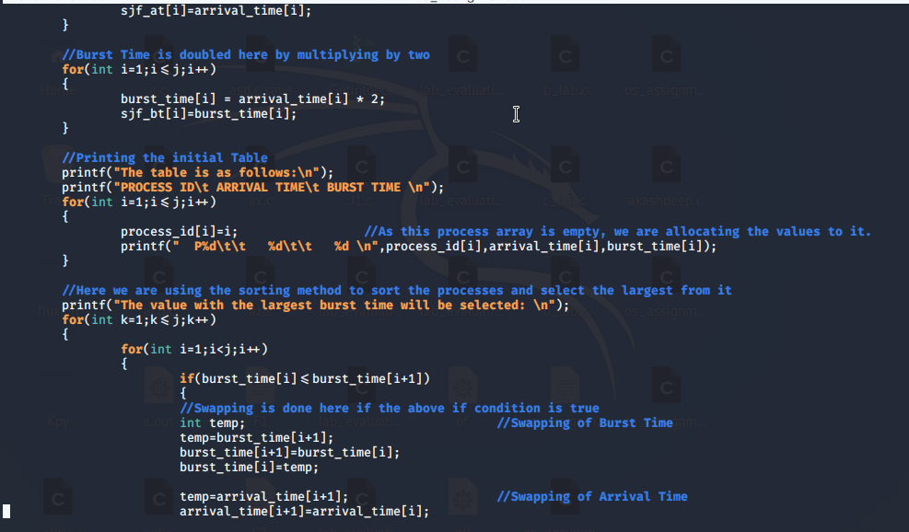
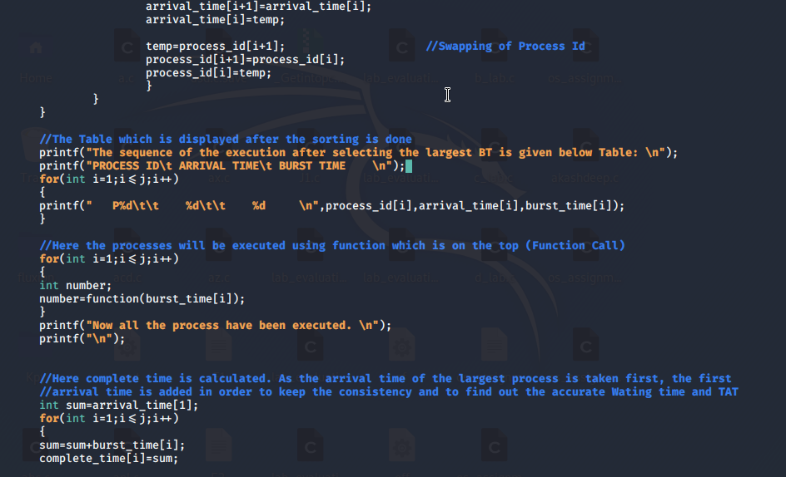

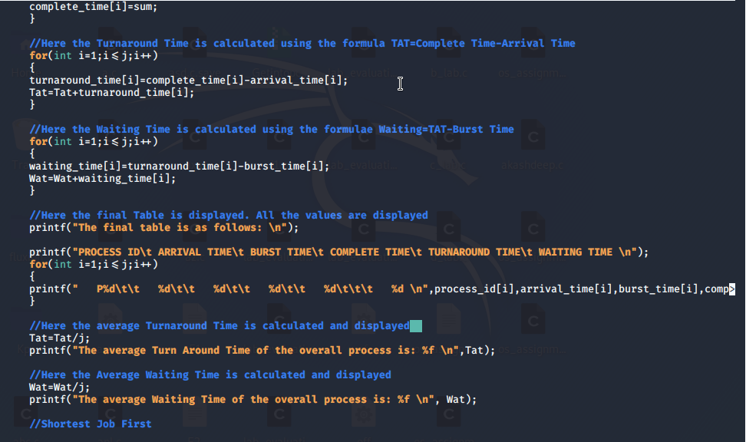

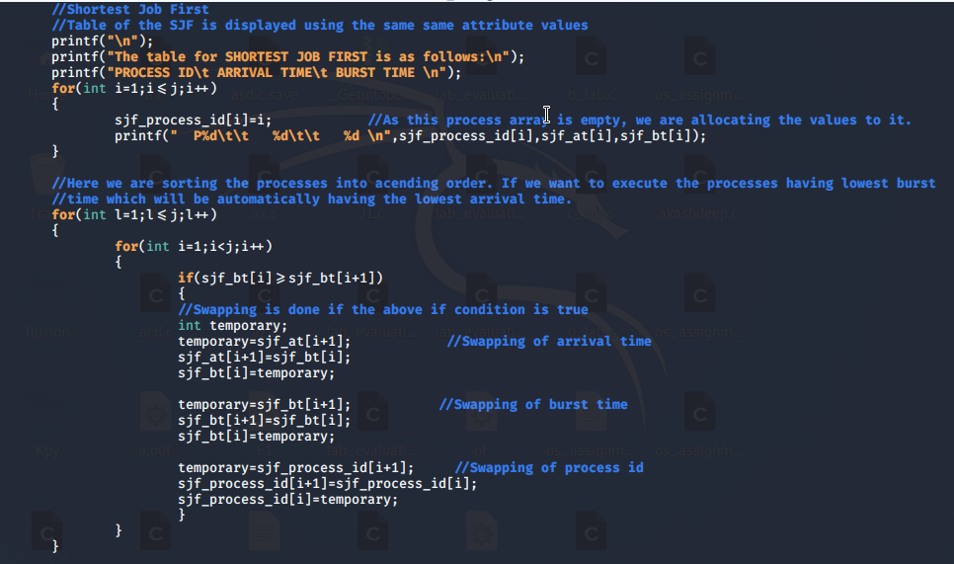

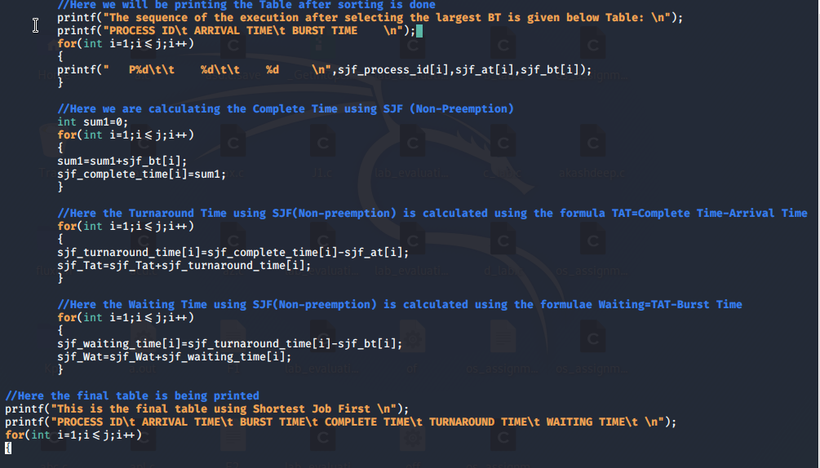
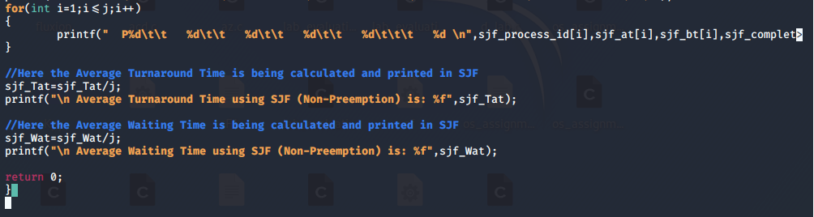

- OUTPUT (TEST CASE):
- First we will be compiling the program and executing it using ./a.out
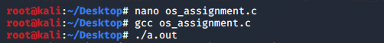

- The program is executed and then we will ask the user to enter the number of processes to be executed. Then we will enter the arrival time for each process.
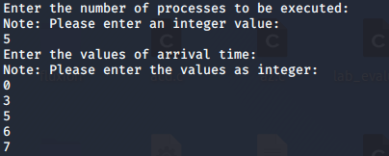

- The table is then printed with Process ID, Arrival Time and Burst Time.
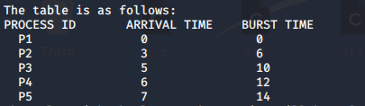

- Then the sorting will be done in Descending order and the value with the largest burst time will be on the top and so on.
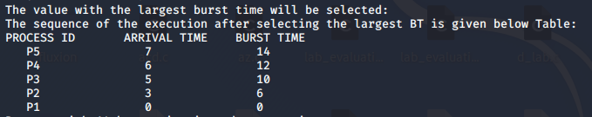

- Processes are in execution as shown in the picture.
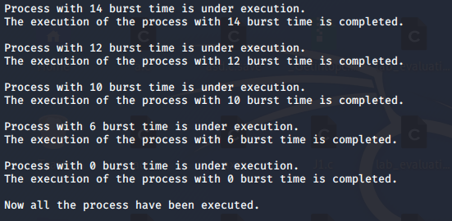

- Then the final table will be displayed with all the values. The average turnaround time and the average waiting time is also displayed below.
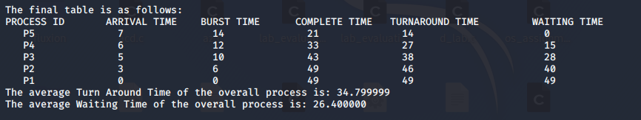

- Then the table for SJF(Non-Preemption) is displayed with the same attribute values.
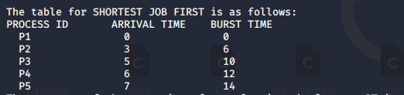

- Then the sorting will take place and the processes will be sorted in ascending order. The table will be displayed with all the values.This sorting is done for two reasons. Firstly the lowest arrival time value will be in the top so that it can be executed first. Secondly, the burst times will be in the sequence which will help for executing the Shortest Job First.
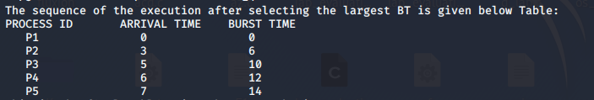
- This is the final table for SJF(Non-Preemption) with all the values and also the Average Waiting Time is given using SJF.
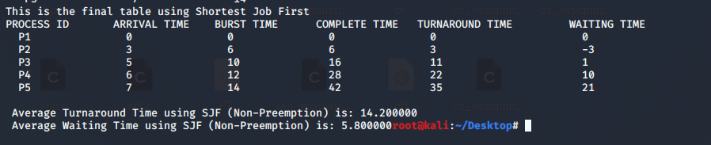

If you have implemented any additional algorithm to support the solution, explain the need and usage of the same.
Answer: There are two places where we have used Bubble Sorting in order to sort the processes. For the first part we have used Bubble Sort in Descending Order so that the process having largest burst time can be selected and executed first and then in sequence all other processes can execute without any inconsistence.
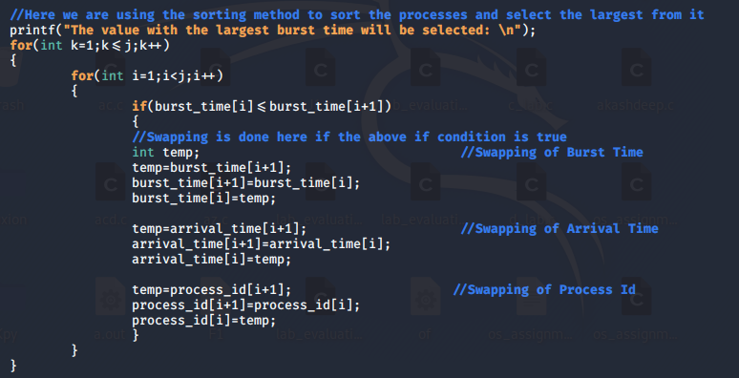

Answer: For the second part we have used Bubble Sort in Ascending Order in SJF section so that the process with lowest arrival time can be selected and executed first and then in sequence all other processes can execute without any inconsistence.

TEST CASES
- First Test Case
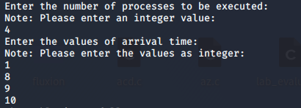
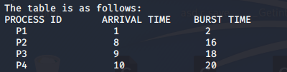
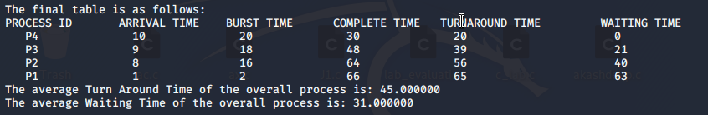
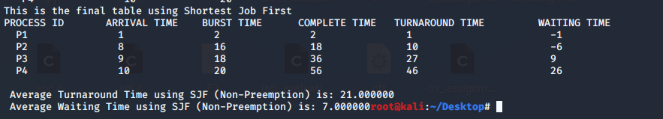
- Second Test Case
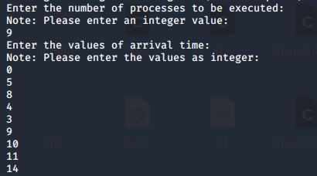
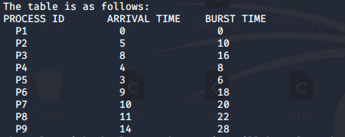
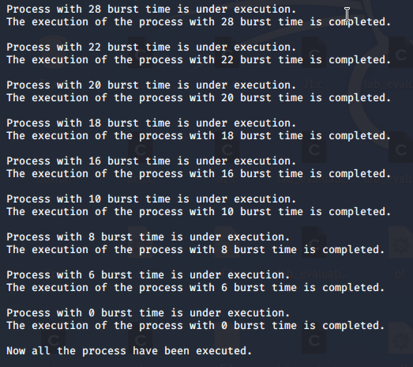
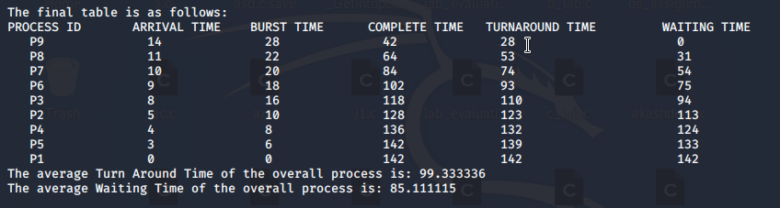
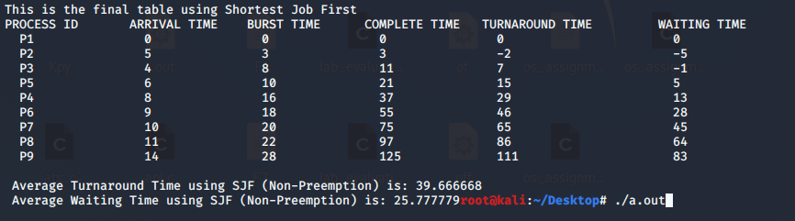

- Third Test Case
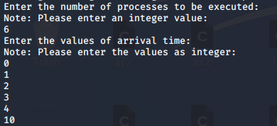
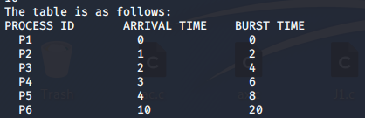
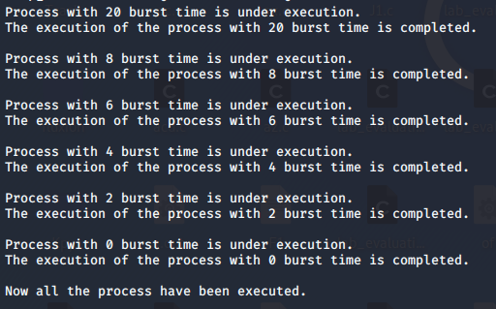
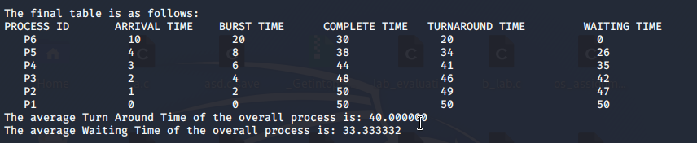
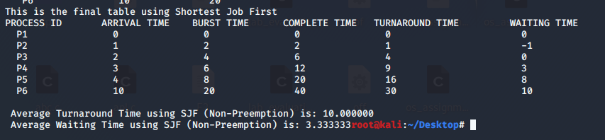

Description: This solved theoretically for the Output(Test Case) for the first code given above.
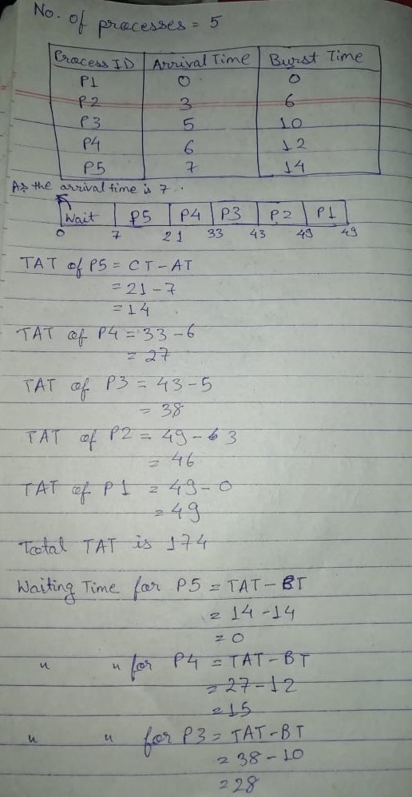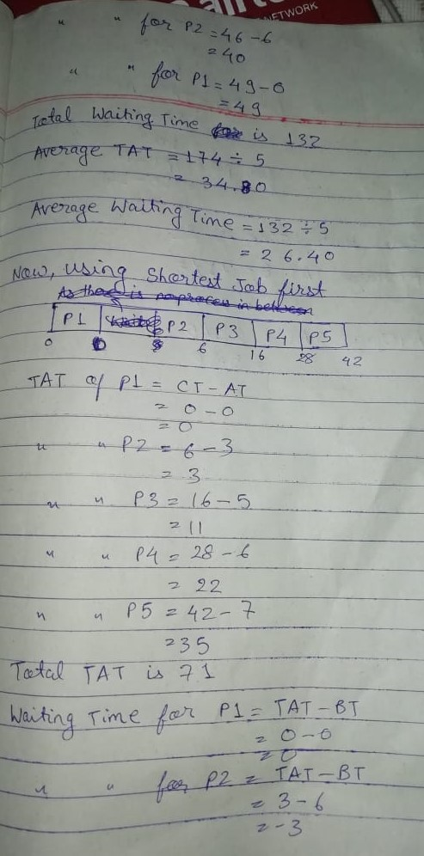
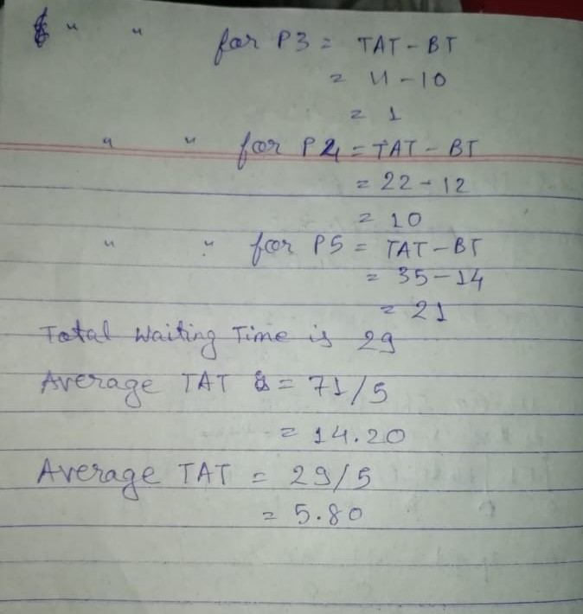

GitHub Link: https://github.com/SatyamRay15/Operating_System_Assignment

